**Software Requirement Specification**

**Project Name: Bed Management Optimization**

**Team Name: Tech Neophytes**

**Team Members:**

**Omika Gari**

**Deepjyoti Roy**

**Deependra Singh Rajput**

**Pulkit Soni**

**Table of Contents:**

1. **Introduction**
   1. Purpose
   2. Scope
   3. Definition/Abbreviations
   4. References
   5. Overview
   6. Intended Audience
2. **Overall Description**
   1. Product Perspective
      1. System Interface
      2. Interfaces
      3. Hardware Interfaces
      4. Software Interfaces
      5. Communication Interfaces
      6. Memory Constraints
      7. Operations
      8. Site adaption requirement
   2. Product Function
   3. User characteristic
   4. Constraints
   5. Operating environment
   6. User environment
   7. Assumption and dependencies
   8. Approximating the requirement
3. **Specific requirement**
   1. External Interface
      1. User Interface
      2. Hardware interface
      3. Software interface
      4. Communication interface
   2. Functions
   3. Performance Requirements
   4. Logical database requirement
   5. Design Constraints
   6. Software System Attributes
      1. Reliability
      2. Availability
      3. Security
      4. Maintainability
      5. Portability
   7. Organizing the specific requirements
      1. System Mode
      2. User case
      3. Objects
      4. Features
      5. Stimulus
      6. Response
      7. Functional Hierarchy
   8. Design Techniques
   9. Additional Comments
4. **Supporting Information**
   1. Appendices
5. **Introduction**

Hospital Bed Management System aims to develop a website that can predict the discharge of the patient and their length of stay in the hospitals. This application uses machine learning algorithm for predicting length of stay of patients in hospital by looking at the initial symptoms of the patient.

Our purpose of the project is to reduce the patients waiting time in emergency departments and having hospitals in increasing their patient flow.

Hence, we have also developed an android application that can help patients to know the number of beds available in the hospital either by searching hospital name or by nearby location.

The process of managing beds is often a tremendous task in almost many hospitals and hence our solution will help in solving the problem of the hospitals as well as patients.

Beds used in a healthcare environment have capabilities that address healthcare needs and/or medical conditions of a patient. However, pairing patients with suitable beds requires an intimate understanding of the capabilities of each bed, as well as, how such capabilities relate to healthcare needs and conditions of patients. Given the large number of bed models available to hospitals and given many bed models have many optional capabilities, determining exactly which bed is “best” or a “good fit” for a given patient's needs can be a daunting task.

Pairing of patients with beds is also dependent upon bed availability. A caregiver may prefer to assign a bed of first class to a patient due to the patient having a healthcare need. All beds of the first class, however, may be currently occupied or otherwise unavailable. An available bed of a second class may have similar attributes to beds of the first class and thus be suitable for the patient. Unless the caregiver is aware of the interchangeability of the beds in these two bed classes in regard to the healthcare need of the patient, the caregiver may assign a less suitable bed of a different class to the patient and/or needlessly rent another bed of the first bed class from a third party distributor in order to accommodate the healthcare need of the patient.

The patient data may include a healthcare code that identifies a medical condition as one of the healthcare attributes of the patient. The healthcare code may also identify a medical procedure as one of the healthcare attributes of the patient.

Optimal patient flow facilitates beneficial treatment, minimal waiting, minimal exposure to risks associated with hospitalization, and efficient use of resources (e.g., of beds, clinical staff, and medical equipment). Patient flow is also a determinant of access to specialized inpatient services. These patients request admission from external sources (e.g., other health services) and internal sources such as the emergency department (ED), procedural areas, or peri-anaesthesia care units (PACUs).

We hypothesize that a predictive model using readily available health information may perform comparable or better than predictions made by clinicians during their daily huddle. We apply supervised machine learning methods to predict the probability of patient discharge by the end of each day (i.e., midnight). By discharging a patient earlier in the day, there is an increased likelihood of admitting a new patient to the same bed, thereby facilitating increased bed utilization and patient flow.

* 1. **Purpose**

The purpose of this project is to develop a website that can help hospitals to predict the time of discharge of patients and their length of stay in hospitals for efficient functioning of hospitals. Patient flow, and by association, bed and capacity management, is a common focus area for operations management methods applied to healthcare.

We hypothesize that a predictive model using readily available health information may perform comparable or better than predictions made by clinicians during their daily huddle. We apply supervised machine learning methods to predict the probability of patient discharge by the end of each day (i.e., midnight). By discharging a patient earlier in the day, there is an increased likelihood of admitting a new patient to the same bed, thereby facilitating increased bed utilization and patient flow.

The proposed system is feasible because:

* The system requires very less time factors.
* The system will provide fast and efficient automated environment instead of slow and

error prone manual system, thus reducing both time and man power spent in running the

system.

* The system will have GUI interface and very less user-training is required to learn it.
* The system will provide service to the patients for various information for proper decision making.
  1. **Scope**

Primarily, the scope pertains to the hospital’s bed management system. Our project will help hospital to predict the length of stay of the patients suffering from major diseases like cancer, diabetes etc. Prediction of length of stay play an important role in bed management. The hospitals will have early awareness about the patients which are going to discharge. Thus, helping the hospitals to maintain patient flow and in determining the availability of beds.

In addition to the website, we have also created an Android Application for the user end. The user will be able to get information about the availability of beds in hospitals around him / her. Also, if the user finds that beds are not available in his/her selected hospital then, he / she can find nearby hospitals within the radius of 10km and get the number of available beds in the snippets.

Predicting hospital LOS allows a hospital to predict discharge dates for a patient admitted to the hospital, which in turn allows improved scheduling of elective admissions leading to reduce variance in hospital bed occupancies. Predicting LOS also allows a hospital to scale its capacity during its long-term strategic planning.

* 1. **Definitions/Abbreviations/ Acronyms**

ML – Machine Learning

SRS – Software Requirement Specification

ER’s – Emergency Department

* 1. **References**
* Research Paper: www.semanticscholars.org
* www.kaggle.com (For dataset)
* Book: Introduction to Machine Learning with Python by Andreas C. Müller and Sarah Guido
* <http://www.tmrfindia.org/ijcsa/v11i33.pdf>
* <https://academic.oup.com/jamia/article/23/e1/e2/2379761>
* https://www.sciencedirect.com/science/article/pii/S0933365700000592
  1. **Overview**

The remaining sections of this document provide a general description, including characteristics of the users of this project, the product's hardware, and the functional and data requirements of the product.  Overall description of the project is discussed in section 2 of this document.  Section 3 gives the specific requirements, data requirements and constraints and assumptions made while designing the Prediction model.  It also gives the user viewpoint of product. Section 3 also discusses the external interface requirements and gives detailed description of functional requirements. Section 4 is for supporting information.

Studies on predicting LOS either attempt to predict LOS assuming “all diseases” hospital or specialty hospital treating only certain diseases. For a general model predicting LOS for any hospital, an improved approach would be to use the disease type variable as input to predict LOS because a certain disease type will have either higher or lower average LOS compared to other disease types.

Systematic experiments applying common supervised machine-learning methods to predict individual patient discharges were performed. These methods included logistic regression (i.e., reference method), classification and regression trees, and tree-based ensemble learning methods. Model parameters and thresholds were tuned for optimal performance with respect to the predictive measures described in the following section. 70 We compared the results among these predictive methods, and then selected the best method to compare to the clinician predictions.

* 1. **Intended Audience**

This project is for the hospitals who want to increase their output by increasing the patient flow in their hospitals. Our target audience is also the patients who want to view their medical reports and can does not want to wait in the hospitals for their treatment. This report contains the overview of the whole system in which each feature is examined according to its precedence.

* 1. **Team Architecture**

Our project is divided into eight modules and there are four members in our team. Each member has worked on two modules.

* **Module 1:**

**Receptionist Module:**

1. **Overall Description**

This document contains the problem statement that the current system and the users are facing which are longer patient wait time and overcrowding / unutilised wards, operation theatres which could be very critical for the patients. It further contains the list of stakeholders and users of the proposed solution. It also briefly describes the major features and a brief description of the proposed system.

The following SRS contains the detailed functions of the proposed system with user characteristics permitted constraints, assumptions and dependencies and requirement subsets.

For impatient care units, two variables play an important role in determining hospital resource utilization. The first variable is predicting a patient’s hospital length of stay (LOS), and second variable is predicting readmissions. Ideally, a hospital must minimize both variables to provide high-quality healthcare and improve resource utilization. Predicting hospital LOS allows a hospital to predict discharge dates for a patient admitted to the hospital, which in turn allows improved scheduling of elective admissions leading to reduce variance in hospital bed occupancies. Predicting LOS also allows a hospital to scale its capacity during its long-term strategic planning

Our hospital bed management system is developed with primary aim of “Saving time” of the patients who need to wait for a long time for the allocation of beds in the hospitals.

* 1. **Product Perspective**
* The proposed system provides mechanism that will predict patient’s length of stay in a hospital for major diseases like Cancer, Diabetes, Lung Infection etc.
* Our system offers operating support for most of the known operating systems.
* The user end application is currently based on Android, but we are willing to move further to other devices as well.
* Though the number of users being supported by the system is precisely not mentioned but the system is able to support many online users at a time.
  + 1. **Hardware Requirements**
* A computer/laptop with internet connectivity.
* Android Device (with minimum version Android 6.0).
* 20 GB HDD
* 256 MB RAM
* Pentium IV Processor
* Input Devices:    Keyboard, Mouse
* Output Devices: Monitor, Printer
  + 1. **Software Requirements**
* A web portal made up using Bootstrap
* MySQL database is used as backend
  + 1. **Communication Requirements**
* Connectivity is done using PHP
  + 1. **Memory Constraints**
* **For Android:**

A memory constraint of 50mb is required

* **For website:**

No memory constraint is required

* + 1. **Operation**
* The patient can view the availability of beds in nearby hospitals using android phone
* The hospital registers and discharge the patients using the website
* The website is operated using ML prediction models
* The website is connected to the visualization software for displaying the infographics to the hospital authorities for taking data driven solutions
  1. **Functionality**

This sub section contains the requirements for the proposed system. These requirements are organized by the features that are refined into use case diagrams and data flow diagram to best capture the functional requirements of the system.

* Self-configured to predict the length of stay of patients
* The system shall display all the patients that are there in the hospital.
* The system shall allow doctors to predict the length of stay based on the symptoms.
* Visualization of the predicted data
* The system can view the data in the form of pie charts, histograms, scattered graphs etc.
* This will help users to view complex data in an infographic form.
* Detailed Bed Availability Categorization
* The system shall display the available beds which will be sub divided into ward types (general ward, OTs, ERs, ICU’s etc).
* Provide search facility
* The system shall allow users (patients) to search hospitals by the name.
* Provide nearby place feature
* The app that is used by the user will provide the nearby hospitals within a given radius along with the availability of beds.
  1. **User characteristics**
* Hospital authorities: They will be able to predict the discharge time and length of stay of patients
* Patients: They will be able to view the nearby hospitals and can view the number of beds available in any hospital in real time
  1. **Constraints**
* Stable and fast internet connection
* Huge data set of the patient so that model can predict well to its environment.
  1. **Operating Environment**

The system may require the following specifications:

* Operating System: Windows / Linux / Mac OS
* Processor: 1.2 GHz ARM processor
* Network: 802.11n Wireless LAN
* Memory: 1GB or more
  1. **User Environment**
* Hospital end:

The hospital will have an admin portal, through which they can register and discharge a patient.

The record of the patient will be stored in the hospital’s database.

* Doctor’s end:

The doctor will diagnose the patient and will update the patient’s health using a website. Our model will predict the discharge time of the patient

* Patients end:

Patient’s will be able to view the available beds in the nearby hospitals

* 1. **Assumption and Dependencies**

**Assumptions**

* The basic assumption is that all hospitals have the records of the patients visited their hospitals.
* All hospitals must have a database of their hospital

**Dependencies**

* Prediction Model
* GPS
  1. **Apportioning the requirement**
* We have taken a sample database for the hospital and patients.
* Our prediction model is based on the sample database

1. **Specific Requirements**
   1. **External Interface**

The external system is to assume full responsibility for storage functions as well as warehouse management and warehouse control for an entire warehouse.    The interfaces in this section are specified by documenting: the name and description of each scheme, source or input, destination or output, ranges, accuracy and tolerances, units of measure, timing, display formats and organization, and data formats. The interfaces in this section are specified by documenting: the name and description of each scheme, source or input, destination or output, ranges, accuracy and tolerances, units of measure, timing, display formats and organization, and data formats.  
The user interface required to be developed for the system should be user friendly and attractive. The interface between the user and the system will be WIMP (Windows, Icons, Menu, Pointers) keeping in mind that the system is to be run through web browser. All operations will be of point and click nature with all navigations performed through windows of the system specifically buttons and menus:  
  
 **Buttons:** The button is activated when the user will click with the left click of the mouse within the bounds of the button. And thus, the action associated with it will be carried out.                                                     
                                                                                                                                                                             **Menu:**  All the operations will be arranged.

* + 1. **User interface**
* **Hospital end:**

The hospital administrator will interact with the website for registering and discharging the patient.

The hospital can analyse the data through the website and will help in increasing the patient flow efficiency

* **Patient’s end:**

The patient will have an interaction with the android devices for looking at the nearby hospitals with vacant beds

* **Doctors’ end:**

The doctor will interact with the website for writing the report after diagnosing the patient

* + 1. **Software interface**
* The website will be connected to the visualization software
* This will help the hospitals to take data driven solution for predicting the bed availability
* The database used with the android phone will be the same that of the hospital’s database
  + 1. **Hardware interface**

There is no hardware interface used

* + 1. **Communication interface**

The website will communicate with the server using localhost.

* 1. **Functions**

The system shall perform the following functions:

* The user can view the available beds in nearby hospitals using the android phone
* The hospitals can visualize the patient’s data and can take data driven solutions
* The hospital can reduce patient’s waiting time and overcrowding at ER’s
* The system can help users at the time of chaos or disasters
  1. **Performance requirements**
* **Prediction:** The model’s prediction accuracy is 85%
* **Security:** The system is secure since a central database is used
* **Concurrent:** The system can support multiple users at the same time
* The system can handle any type of information
* **Failure handling:** At the time of failure the system needs to be backed up
* **Backup:** The database is provided with the backup in case of system failure
  1. **Logical database requirements**

**// ER Diagram**

**Table: Hospital**

* Hospital ID
* Hospital Name
* Hospital Address
* Total beds
* Total available beds
* Total occupied beds

**Table: Patients**

* Patient ID
* Patient name
* Patient age
* Patient gender
* Hospital ID

**Table: Wards**

* Ward ID
* Ward name
* Patient ID

**Table: Doctors**

* Doctor ID
* Doctor name
* Patient ID
* Hospital ID

**Table: Disease**

* Disease Symptoms
* Patient ID
  1. **Design Constraints**
* The prediction of only few diseases are predicted
* The android application shows the hospital with available number of beds in green colour whereas the hospital with non-availability of beds in red colour
  1. **Software System Attributes**

System attributes that must be achieved in every SRS are as follows:

* + 1. **Reliability**

The capability to maintain the specified level of performance is meant by reliability. This application will run on any android phone

* + 1. **Availability**

The application will run 24 * 7 if internet connection is available

* + 1. **Security**
* Security requirements placed restrictions to other users, only hospital authority can access the website.
* The android phone does not have any restriction and can be used by anyone in case of emergency
  + 1. **Maintainability**
* The system application needs to be maintained on real time basis. The admin can add and update any new feature as per the hospital’s requirement
* The android application’s database must be updated by the hospital at time of every registration and discharge of patient
  + 1. **Portability**

The android phones are portable; hence the application will also be portable.

* 1. **Organizing the specific requirements**

For a trivial system, the requirements tend to be extensive. For this reason, it is necessary to take careful consideration for optimal understanding.

* + 1. **System Mode**

Active: The android application would work in active state/mode

Analytics: The website will be used to predict the discharge time of the patients based on the regression model used for prediction. Hence, this system will be of Analytics mode.

* + 1. **Objects**

Objects are real-world entities that have a counterpart within the system. Associated with each object is a set of attributes and functions. These functions are also called services, methods, or processes. Sets of objects may share attributes and services. These are grouped together as classes.

In our module, we have grouped Patient, Doctors, Wards and Hospital as classes

* + 1. **Features**

The features of our application are:

Android:

* Patients will able to view the number of beds in the nearby hospital.
* Patients can search a hospital using search by hospital option and can see the number of beds available in that hospital
* The android application will show the hospitals with available beds in green colour and the hospitals with no available beds in red colour

Website:

* The website will have the feature of predicting the discharge time of the patients
* Data driven solutions can be obtained using the website in the form of infographics
* The website will be helpful in reducing the patient’s waiting time and overcrowding at ER’s
  + 1. **Design Techniques**
* **Bootstrap**

Bootstrap is a free and open-source front-end Web framework. It contains HTML and CSS-based design templates for typography, forms, buttons, navigation and other interface components, as well as optional JavaScript extensions. Unlike many earlier web frameworks, it concerns itself with front-end development only.

Bootstrap is used to design our front-end application of the website

* **PHP**

Hypertext Pre-processor is a general-purpose programming language originally designed for web development.

It is used for connecting the database from website and Android application

* **My SQL**

MySQL is an open source relational database management system.

Modern day web sites seem to be relying more and more on complex database systems. These systems store all of their critical data and allow for easy maintenance in some cases.

The Structured Query Language (SQL) is a very popular database language, and its standardization makes it quite easy to store, update and access data. One of the most powerful SQL servers out there is called MySQL and surprisingly enough, its free.

Some of the features of MySQL Include: Handles large databases, in the area of 50,000,000+ records. No memory leaks. Tested with a commercial memory leakage detector (purify). A privilege and password system which is very flexible and secure, and which allows host-based verification. Passwords are secure since all password traffic when connecting to a server is encrypted.

* **Machine Learning**

**Machine learning** is an application of artificial intelligence (AI) that provides systems the ability to automatically learn and improve from experience without being explicitly programmed. **Machine learning** focuses on the development of computer programs that can access data and use it learn for themselves.

We have used regression model in our application for predicting

* **Android**

Android is a mobile operating system developed by Google. It is based on a modified version of the Linux kernel and other open source software and is designed primarily for touchscreen mobile devices such as smartphones and tablets.

**3.7.5 Additional Comments**

* Sample database is used for prediction
* Prediction model of only few diseases are determined.

1. **Design** 
   1. **Process Model**

* **Receptionist Module**

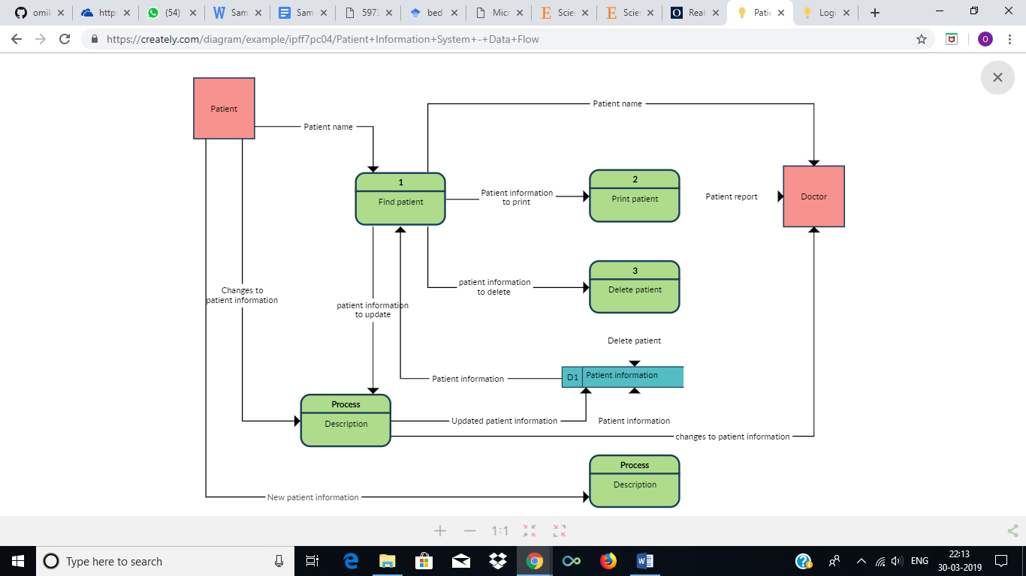

* 1. **Use case**

**Receptionist Module**

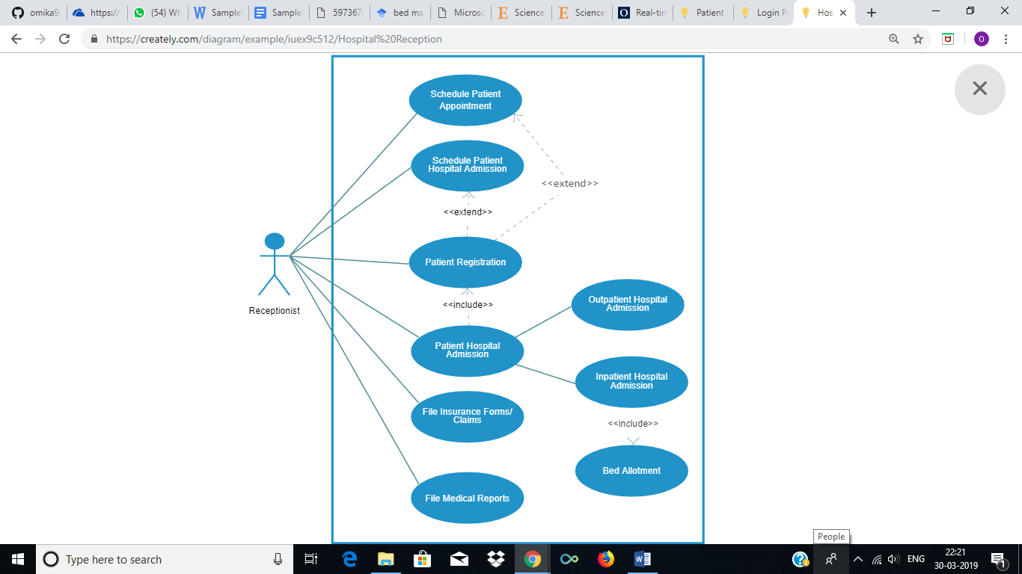

* 1. **Class diagram**
  2. **Data Flow diagram**

1. **Supporting Information** 
   1. **Appendices**